Mathematics
Multiple choices
- A prism has
- Only triangular faces.
- No point.
- Curved faces.
- Parallelogram sides.

- All of the sides of this triangle are equal. What kind of a triangle is this?
- scalene
- isosceles
- equilateral
- right triangle
- A scalene triangle has
- Three equal sides.
- Three uneven sides.
- Two equal sides.
- Two square corners.
- John's teacher asked him to draw a quadrilateral with all congruent sides. What could he draw?
- a rectangle or a rhombus
- a rectangle or a square
- a square or a rhombus
- a trapezoid or a kit
- Which of the following could be the side lengths of a right triangle?
- 3, 13, and 14
- 4, 5, and 6
- 4, 9, and 10
- 5, 10, and 15
- 5, 12, and 13
- Which one is NOT a name for this figure?
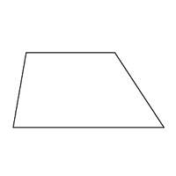
- polygon
- quadrilateral
- parallelogram
- triangle
- Which statement about quadrilaterals is true?
- All rectangles are always squares.
- All squares are always rhombuses.
- All trapezoids are always parallelograms.
- All rectangles are always parallelograms
- How many faces does a cube have?
- 4
- 6
- 8
- 10
- How many millimeters are in a meter?
- 1
- 10
- 100
- 1000
- An acute triangle is a triangle with acute angles.
- one
- two
- three
- four
- A parallelogram is a square.
- never
- sometimes
- always

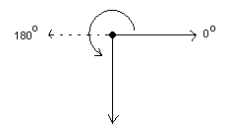
What is the measure of the solid line angle depicted by the following figure?

- 90 degrees
- 180 degrees
- 225 degrees
- 270 degrees
- 0 degrees
True of false
- Angles are measure in degrees
- True
- False
- The sum of angles at a point add up to 270 degrees
- True
- False
- Corresponding terms for Pattern A and Pattern B are shown.
Pattern A: 8, 12, 16, 20
Pattern B: 24, 36, 48, 60
each term in Pattern A is 3 times the corresponding term in Pattern B.
- True
- False
- All angle in a cyclic triangle do not add up to 360 degrees
- True
- False
- An isosceles triangle has three congruent sides.
- True
- False
- Some quadrilaterals are parallelograms.
- True
- False
- A triangular pyramid is 3 dimensional shape with five vertices
- True
- False

- This quadrilateral is a parallelogram.
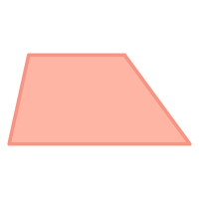
- True
- False
- the sum of the measures of the interior angles of a hexagon is 720°
- True
- False

Short answer
- Lucy says the shape shown is not a parallelogram because all four sides are not the same length. Is Lucy's reasoning correct and why?
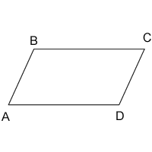

- This triangle has no congruent sides. State the qualities of the triangles and name the triangle
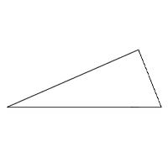
- The table shows the side lengths of quadrilateral ABCD.
Quadrilateral ABCD
Side | Length
AB | 4
BC | 8
CD | 6
DA | 6
Is quadrilateral ABCD a parallelogram?
- Which of the following are parallelograms? Give a reason
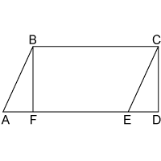.
- State the key feature of right angled triangle
- Why the shape shown is not a parallelogram?
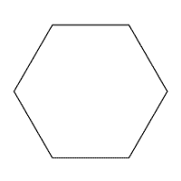
Calculations
- Side AC of the triangle measures 4 units and side BC measures 3 units.
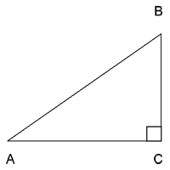
If you plot the triangle on a coordinate plane with point A at the origin (0, 0) and point C at (4, 0), what are the coordinates of point B?
- Find the measure of the missing angle in the triangle below.
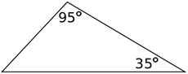

- The figure below is a parallelogram with two angles given in terms of x. Determine the value of x.
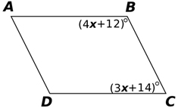

- The figure below is an equilateral triangle with sides of length 6. What is the area of the triangle?
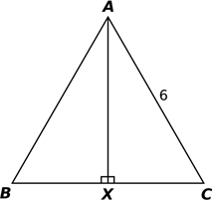
- Each cube measures 1 cubic unit in volume. What is the total volume of all the cubes combined?
- In this right rectangular prism, each small cube measures 1 centimeter on each side.
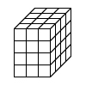
How many cubes make the prism?

- Calculate the values of angles at a point in the figure below

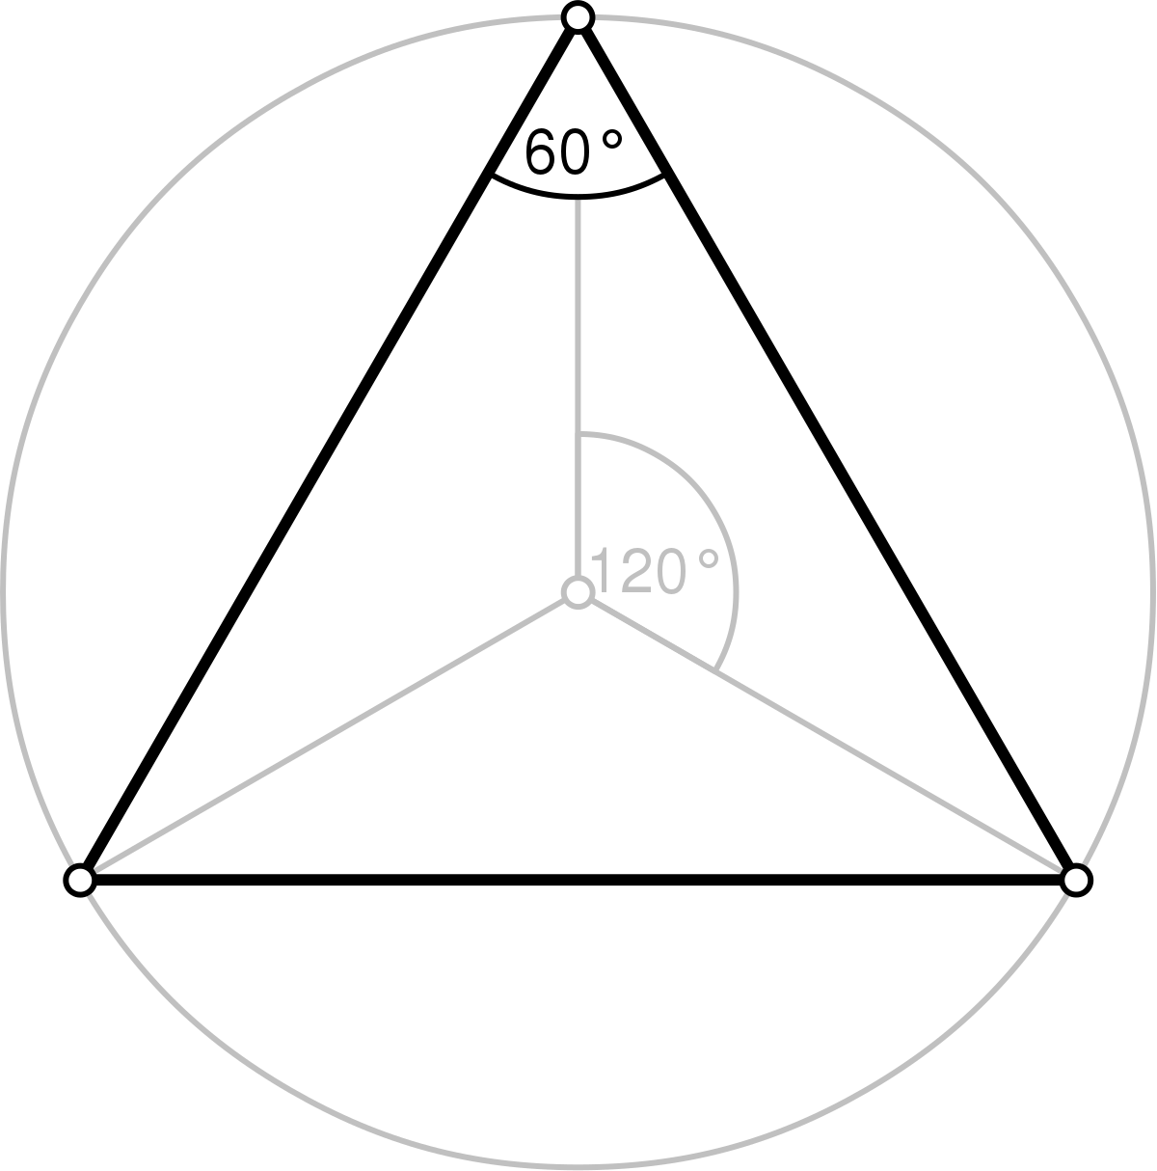
- Tom made a figure that was 4 cubes long, 3 cubes wide and 1 cube high. How many cubes did he use?

Measurement and construction
- Using a protractor measure the angles in the figure below.

- Using a pair of compass and a rule, construct a triangle measuring 3cm by 5cm by 4cm. state the type of triangle.
- Using the triangle drawn above calculate the value of angle in the diagram. Calculate the area of the triangle.
- Represent the following coordinates of triangle and state the type of triangle (7,0), (3,7), (0,5)

- According to angle measure, what kind of triangle is this? Measure all side using a rule
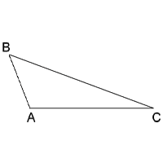

Answer key
Factual Questions
Multiple choices
- Only triangular faces
- equilateral
- Three uneven sides
- a trapezoid or a kit
- 5, 12, and 13
- Triangle
- All rectangles are always parallelograms
- 6
- 1000
- A triangle with three acute angles
- never
- 270 degrees
Knowledge Questions
True or false
- True
- False
- True
- False
- true
- False
- True
- True
- True
Evaluation Questions
Short answer
- No, Lucy is incorrect. The shape is a parallelogram because it has four sides and the opposite sides are parallel.
- This is a scalene triangle. It qualities are; unequal side or angles, the angle of the triangle can be acute angles, obtuse angle or right angle. The triangle has no line of symmetry.
- Maybe. It could be a parallelogram, but the table needs to include angle measures in order to determine.
- ABCE, line AE is parallel to line BC (only one answer is required).
- All right triangles have 90-degree, or right angles
- It has more than four sides.
Calculations
- (3,4)
- 50
- X=22
- 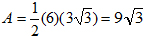
- 15 cubic units
- 48 cubes (learners should demonstrate multiplication method).

- All angle are 120 degrees
- 12
Comprehension Questions
Measurements and construction
- Angle 60, 30
- Right angled triangle
- Area = 6 square cm.
- Right angle triangle
- acute triangle AB= 1.5cm, AC= 3.1, BC=3.7 (accept +_ 1)

